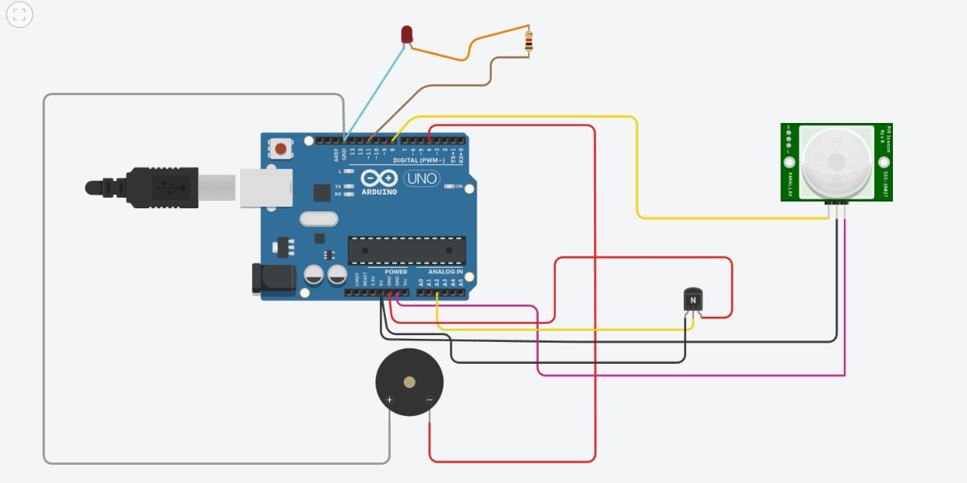

// C++ code

//

void setup()

{

pinMode(11, OUTPUT);//led

pinMode(4,OUTPUT);//buzzer

}

void loop()

{

int l=digitalRead(8);

double p=analogRead(A2);

double q=p/1020;

double temp=q\*5;

double k=temp-0.5;

double s=k\*90;

if(s<50)

{

digitalWrite(4, HIGH);

}

else

{

digitalWrite(4, LOW);

}

if(l==1)

{

digitalWrite(11, HIGH);

}

else

{

digitalWrite(11, LOW);

}

}